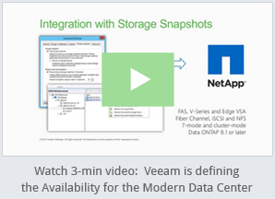

<http://www.veeam.com/netapp-snapshot-snapvault-snapmiror-integration.html>

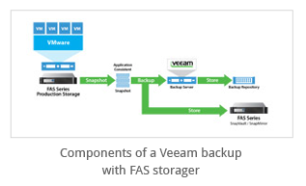

<http://img.veeam.com/product_pages/v8/netapp_2_t.jpg>

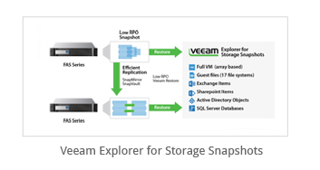

<http://img.veeam.com/product_pages/v8/netapp_1_t.jpg>

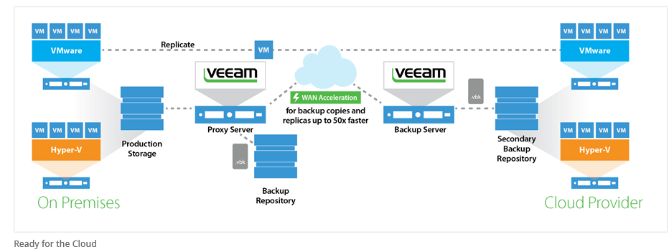

<http://img.veeam.com/product_pages/v8/netapp_3.jpg>



<http://fast.wistia.net/embed/iframe/w5k601c6f6?popover=true&ad=in-text-link>

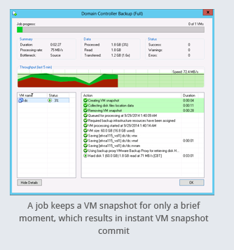

<http://img.veeam.com/product_pages/v8/screenshots/220_san_snapshot_hl.png>

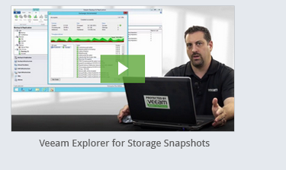

<http://www.veeam.com/backup-from-storage-snapshots.html>

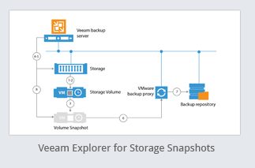

<http://img.veeam.com/product_pages/v8/bfss-scheme-t.jpg>

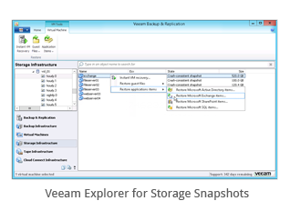

<http://img.veeam.com/product_pages/v8/screenshots/san_IR.png>

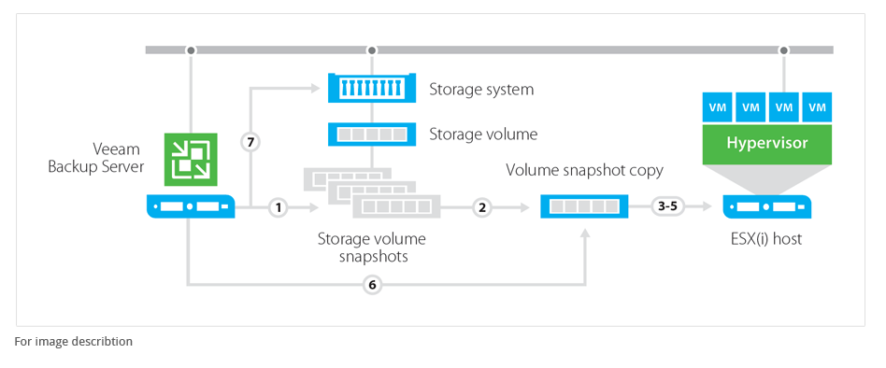

<http://go.veeam.com/storage-snapshots-explorer.html> (How it works)